Ruchita_Trivedi / STAT-6610/ HW-4
____________________________________________________________________
- Complete the Activity Two, we did not work this activity in class. Show that you attempted the Activities that were discussed in class. We worked on Activity One, Activity Six, and Activity Four.

Activity 1:
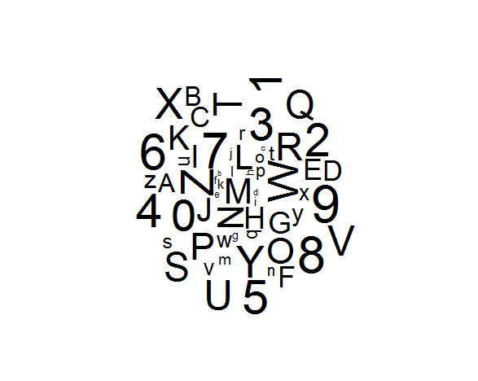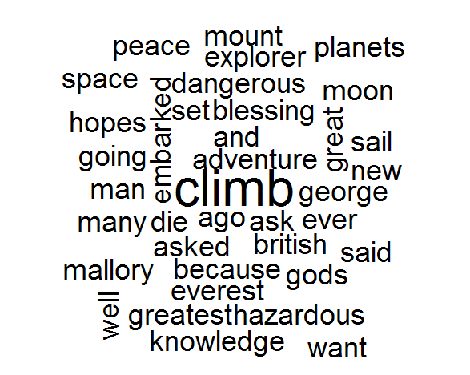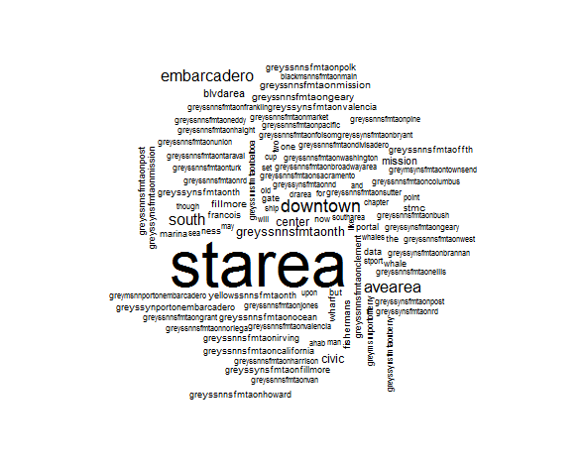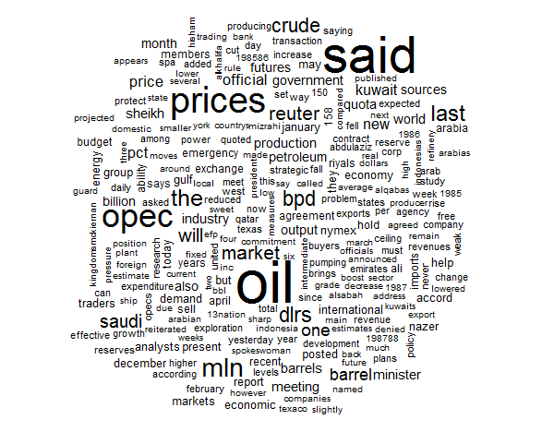

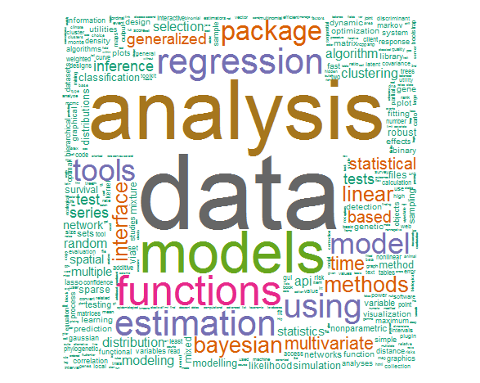

Activity 2:

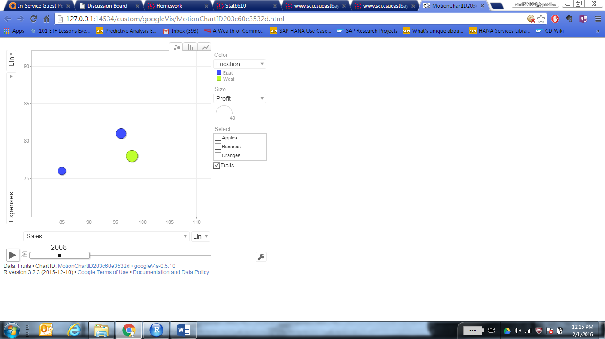

(Activity 4 Completed, dint find anything to document)

Activity Six:

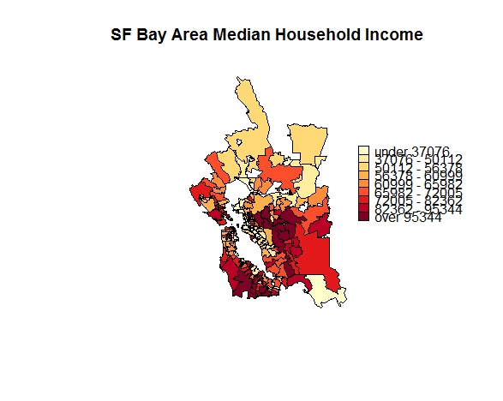

2.Make another wordcloud from Activity One. Find a different document/book 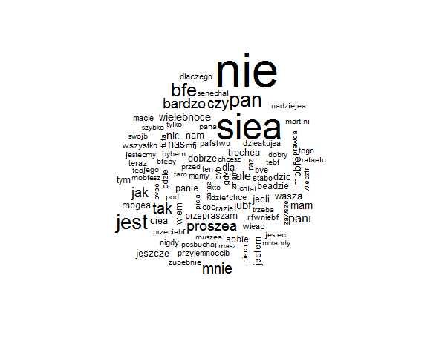

_____________________________________________________________________________________
- Make a map from Activity Three.

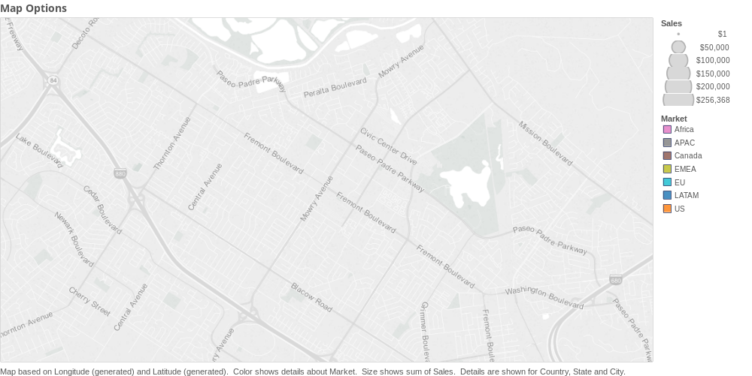
I plotted countries to the level of detail of state and city on map.
Identified different markets by different color scheme.
Represented cities using symbols.
Represented Postal Codes and State using filled Maps and Symbols
Customised Maps by using the Map Options , enabled the search menu , looked at Streets and Highway names of Freemont California (as shown above)

_____________________________________________________________________________________

4.Make a heatmap in plot.ly from Activity Five.
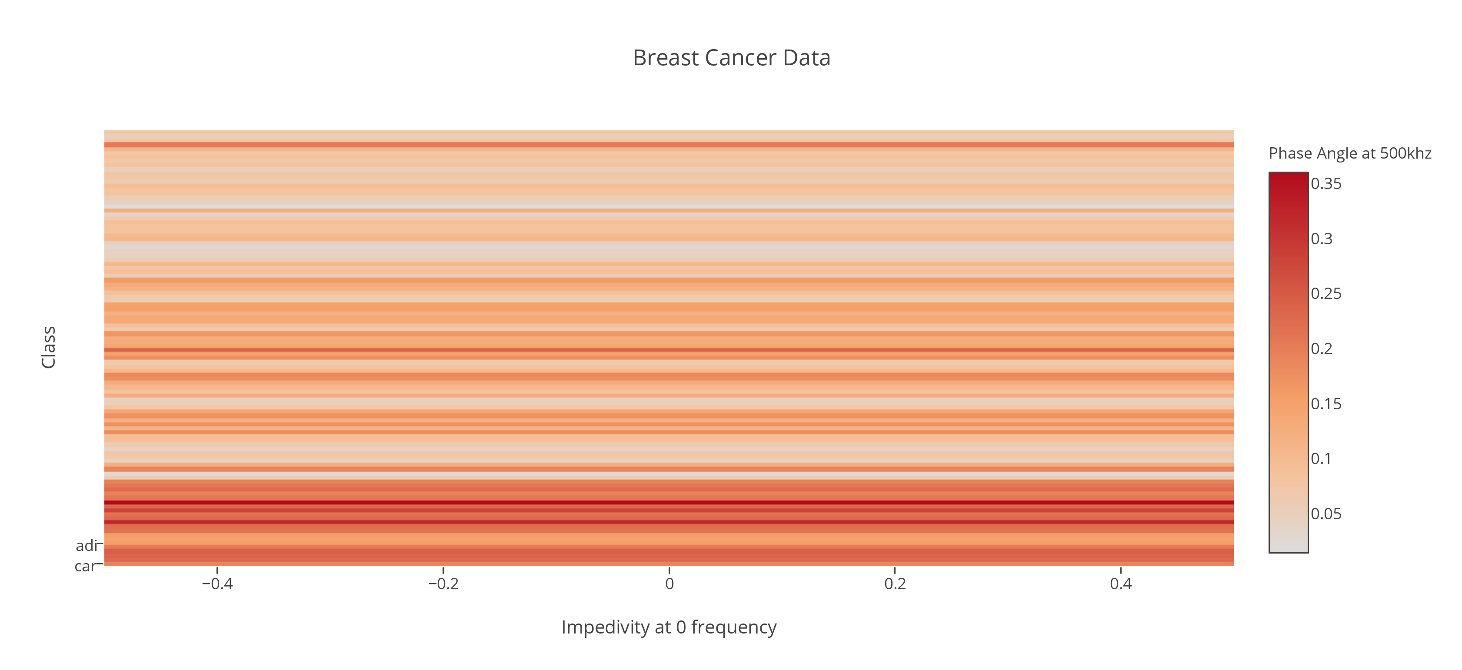

- Make a map of the Bay Area from Activity Six.
Completed this Activity for question 1 above, please find the map figure in answer 1.

- Using R run the mtcars examples from the end of the Tools2 presentations. Show the plots you have created in your homework document.

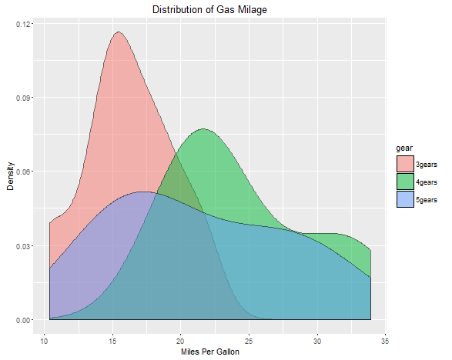
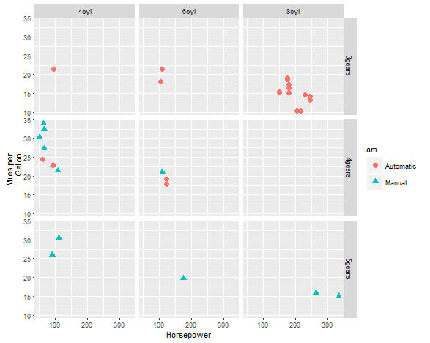

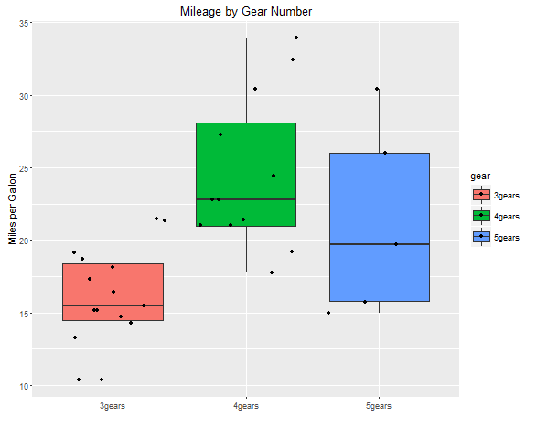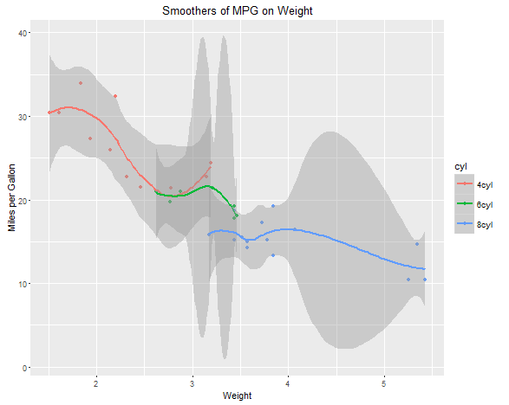
_____________________________________________________________________________________

8. From the Quick-R website run the R code related to the following topics. See the Advanced Graphs links.Show the plots you have created in your homework document.
a. Lattice Plots
b .ggplot2
c. Probability Plots
d. Mosaic Plots
e. Correlograms
Lattice Plot:
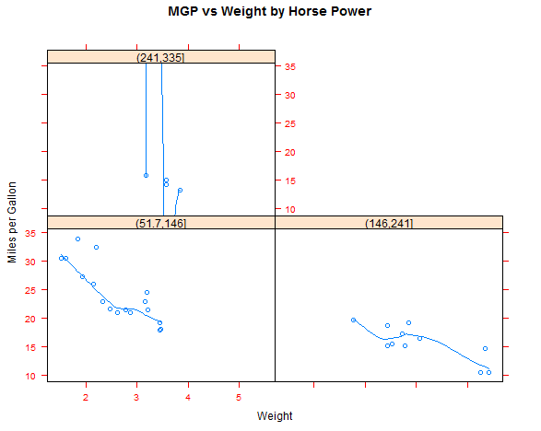

GG-Plot
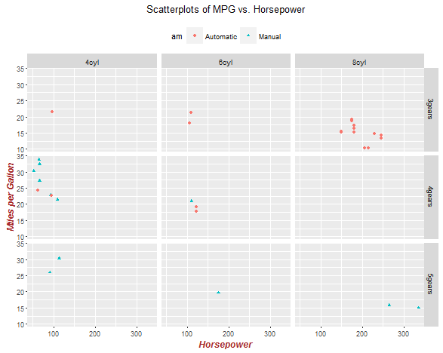
Probability Plot:
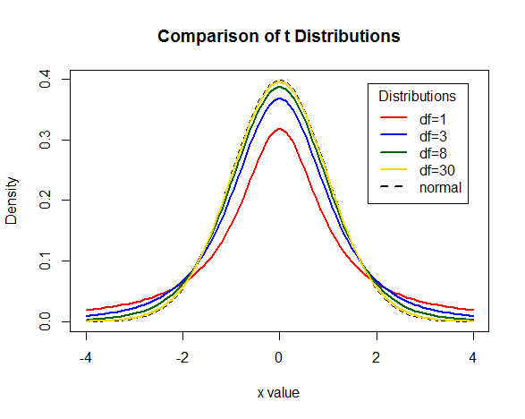

Mosaic Plot:
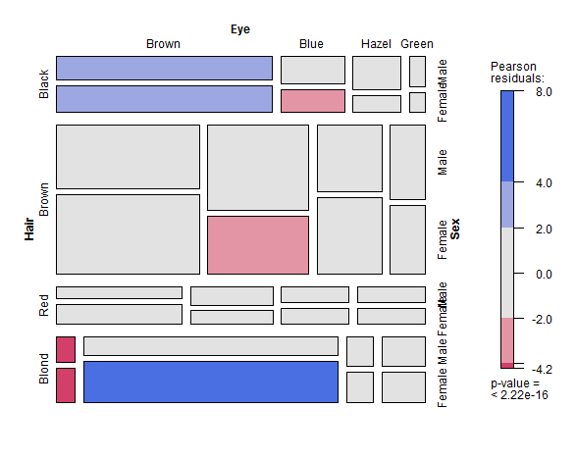

Correlogram:
